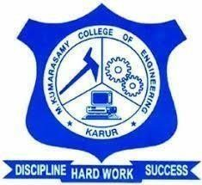 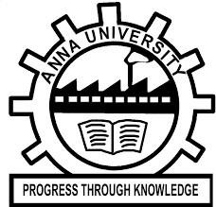

# ECO-FRIENDLY WASTE BURNER A PROJECT REPORT

**NITHISH N (927622BME060)**

**POOVARASAN P (927622BME061)**

**MUGUNTHAN U (927622BME312)**

***in partial fulfillment for the award of the degree***

***of***

## BACHELOR OF ENGINEERING

**IN  
  
MECHANICAL ENGINEERING**

**M. KUMARASAMY COLLEGE OF ENGINEERING, KARUR**

## ANNAUNIVERSITY: CHENNAI 600025

**MAY 2024**

 

# ECO-FRIENDLY WASTE BURNER A MINOR PROJECT REPORT

***Submitted by***

**NITHISH N (927622BME060)**

**POOVARASAN P (927622BME061)**

**MUGUNTHAN U (927622BME312)**

***in partial fulfillment for the award of the degree of***

**BACHELOR OF ENGINEERING**

***in***

## MECHANICAL ENGINEERING

**M. KUMARASAMY COLLEGE OF ENGINEERING, KARUR**

## ANNA UNIVERSITY: CHENNAI 600025

**MAY 2024**

# M. KUMARASAMY COLLEGE OF ENGINEERING, KARUR

## BONAFIDE CERTIFICATE

Certified that this project report “**ECO-FRIENDLY WASTE BURNER”** is the bonafide work of **“NITHISH N (927622BME060), POOVARASAN P (927622BME061), MUGUNTHAN U (927622BME312)”** who carried out the project work during the academic year 2023 – 2024 under my supervision. Certified further, that to the best of my knowledge the work reported here in does not form part of any other project report or dissertation on the basis of which a degree or award was conferred on an earlier occasion on this or any other candidate.

|  |  |
| --- | --- |
| **SIGNATURE** | **SIGNATURE** |
| Mrs.D.Umamaheswari M.E., | Dr.M.Loganathan M.E., Ph.D. |
| **SUPERVISOR** | **HEAD OF THE DEPARTMENT** |
| Department of Mechanical Engineering, | Department of Mechanical Engineering, |
| M. Kumarasamy College of Engineering, | M. Kumarasamy College of Engineering, |
| Thalavapalayam, Karur - 639113. | Thalavapalayam, Karur - 639113. |

This project report has been submitted for the end semester project viva voce Examination held on ________________

INTERNAL EXAMINER EXTERNAL EXAMINER

ii

DECLARATION

We affirm that the Project titled **“ECO-FRIENDLY WASTE BURNER”** being submitted in partial fulfillment off or the End Semester Examination of **B.E. MECHANICAL ENGINEERING**, is the original work carried out by us. It has not formed the part of any other project or dissertation on the basis of which a degree or award was conferred on an earlier occasion on this or any other candidate.

Student Name Signature

1. NITHISH N ---------------------------
2. POOVARASAN P ---------------------------
3. MUGUNTHAN U ---------------------------

Name and signature of the supervisor with date

iii

**ACKNOWLEDGEMENT**

Our sincere thanks to Thiru**. M. Kumarasamy**, Founder and **Dr. K. Ramakrishnan**, Chairman of M. Kumarasamy College of Engineering for providing extraordinary infrastructure, which helped us to complete the project in time.

It is a great privilege for us to express our gratitude to our esteemed Principal **Dr. B.S. Murugan M.E, ph.D** for providing us right ambiance for carrying out the project work.

We would like to thank **Dr.M.Loganathan M.E., Ph.D.,** Head, Department of Mechanical Engineering, for his unwavering moral support throughout the evolution of the project.

We offer our whole hearted thanks to our internal guide **Mrs.D.Umamaheswari M.E.,** Assistant Professor, Department of Mechanical Engineering, for her constant encouragement, kind co-operation, valuable suggestions and support rendered in making our project a success.

We offer our whole hearted thanks to our project coordinator **Mr.S.Saravanakumar M.Tech, (Ph.D),** Assistant Professor, Department of Mechanical Engineering, for his constant encouragement, kind co-operation, valuable suggestions and support rendered in making our project a success.

We glad to thank all the Teaching and Non-Teaching Faculty Members of Department of Mechanical Engineering for extending a warm helping hand and valuable suggestions throughout the project.

Words are boundless to thank Our Parents and Friends for their constant encouragement to complete this project successfully.

iv

**INSTITUTIONVISION&MISSION**

**Vision**

* To emerge as a leader among the top institutions in the field of technical education.

**Mission**

* Produce smart technocrats with empirical knowledge who can surmount the global challenges.
* Create a diverse, fully-engaged, learner-centric campus environment to provide quality education to the students.
* Maintain mutually beneficial partnerships with our alumni, industry and professional associations.

**DEPARTMENT VISION, MISSION, PEO, PO & PSO**

**Vision**

* To create globally recognized competent Mechanical engineers to work in multi-cultural environment.

**Mission**

* To impart quality education in the field of mechanical engineering and to enhance their skills, to pursue careers or enter into higher education in their area-of-interest.
* To establish a learner-centric atmosphere along with state-of-the-art research facility.
* To make collaboration with industries, distinguished research institution and to become a center of excellence

**PROGRAMEDUCATIONALOBJECTIVES(PEOS)**

The graduates of Mechanical Engineering will be able to

* PEO1: Graduates of the program will accommodate insightful information of engineering principles necessary for the applications of engineering.
* PEO2: Graduates of the program will acquire knowledge of recent trends in technology and solve problem in industry.
* PEO3: Graduates of the program will have practical experience and interpersonal skills to work both in local and international environments.
* PEO4: Graduates of the program will possess creative professionalism, understand their ethical responsibility and committed towards society.

v

**PROGRAM OUTCOMES**

**The following are the Program Outcomes of Engineering Graduates will be able to:**

1. **Engineering knowledge:** Apply the knowledge of mathematics, science, engineering fundamentals, and an engineering specialization to the solution of complex engineering problems.
2. **Problem analysis:** Identify, formulate, review research literature, and analyze complex engineering problems reaching substantiated conclusions using first principles of mathematics, natural sciences, and engineering sciences.
3. **Design / Development of solutions:** Design solutions for complex engineering problems and design system components or processes that meet the specified needs with appropriate consideration for the public health and safety, and the cultural, societal, and environmental considerations.
4. **Conduct investigations of complex problems:** Use research-based knowledge and research methods including design of experiments, analysis and interpretation of data, and synthesis of the information to provide valid conclusions.
5. **Modern tool usage:** Create, select, and apply appropriate techniques, resources, and modern engineering and IT tools including prediction and modeling to complex engineering activities with an understanding of the limitations.
6. **The engineer and society:** Apply reasoning informed by the contextual knowledge to assess societal, health, safety, legal and cultural issues and the consequent responsibilities relevant to the professional engineering practice.
7. **Environment and sustainability:** Understand the impact of the professional engineering solutions in societal and environmental contexts, and demonstrate the knowledge of, and need for sustainable development.
8. **Ethics:** Apply ethical principles and commit to professional ethics and responsibilities and norms of the engineering practice.
9. **Individual and team work:** Function effectively as an individual, and as a member or leader in diverse teams, and in multidisciplinary settings.
10. **Communication:** Communicate effectively on complex engineering activities with the engineering community and with society at large, such as, being able to comprehend and write effective reports and design documentation, make effective presentations, and give and receive clear instructions.
11. **Project management and finance:** Demonstrate knowledge and understanding of the engineering and management principles and apply these to one’s own work, as a member and leader in a team, to manage projects and in multidisciplinary environments.
12. **Life - long learning:** Recognize the need for, and have the preparation and ability to engage in independent and life -long learning in the broadest context of technological change.

vi

**PROGRAM SPECIFIC OUTCOMES (PSOs)**

**The following are the Program Specific Outcomes of Engineering Graduates:**

The students will demonstrate the abilities

1. **Real world application:** To comprehend, analyze, design and develop innovative products and provide solutions for the real-life problems.
2. **Multi-disciplinary areas:** To work collaboratively on multi-disciplinary areas and make quality projects.
3. **Research oriented innovative ideas and methods:** To adopt modern tools, mathematical, scientific and engineering fundamentals required to solve industrial and societal problems.

|  |  |  |
| --- | --- | --- |
| **Course Outcomes** | At the end of this course, learners will be able to: | **Knowledge Level** |
| CO - 1 | Identify the issues and challenges related to industry, society and environment. | Apply |
| CO - 2 | Describe the identified problem and formulate the possible solutions. | Apply |
| CO -3 | Design / Fabricate new experimental set up/devices to provide solutions for the identified problems | Analyse |
| CO -4 | Prepare a detailed report describing the project outcome | Apply |
| CO - 5 | Communicate outcome of the project and defend by making an effective oral presentation. | Apply |

**MAPPING OF PO & PSO WITH THE PROJECT OUTCOME**

|  |  |  |  |  |  |  |  |  |  |  |  |  |  |  |  |
| --- | --- | --- | --- | --- | --- | --- | --- | --- | --- | --- | --- | --- | --- | --- | --- |
| **Course Outcomes** | **Program Outcomes** | | | | | | | | | | | | **Program Specific Outcomes** | | |
| 1 | 2 | 3 | 4 | 5 | 6 | 7 | 8 | 9 | 10 | 11 | 12 | 1 | 2 | 3 |
| CO - 1 | 3 | 3 | 3 | 3 | 2 | 2 | 2 | 2 | 3 | 3 | 2 | 2 | 3 | 2 | 3 |
| CO - 2 | 3 | 3 | 3 | 3 | 2 | 2 | 2 | 2 | 3 | 3 | 2 | 2 | 3 | 2 | 3 |
| CO - 3 | 3 | 3 | 3 | 3 | 2 | 2 | 2 | 2 | 3 | 3 | 2 | 2 | 3 | 2 | 3 |
| CO - 4 | 3 | 3 | 3 | 3 | 2 | 2 | 2 | 2 | 3 | 3 | 2 | 2 | 3 | 2 | 3 |
| CO - 5 | 3 | 3 | 3 | 3 | 2 | 2 | 2 | 2 | 3 | 3 | 2 | 2 | 3 | 2 | 3 |

vii

**TABLE OF CONTENTS**

|  |  |  |
| --- | --- | --- |
| **CHAPTER**  **NO.** | **CONTENT** | **PAGE**  **NO.** |
| **ABSTRACT** | | **3** |
| **1** | **INTRODUCTION**   |  |  | | --- | --- | | **1.1** | **DESCRIPTION** | | **1.2** | **PROBLEM STATEMENT** | | **1.3** | **OBJECTIVES** | | **4**   |  | | --- | | **4** | | **6** | | **6** | |
| **2** | **PROJECT METHODOLOGY**   |  |  | | --- | --- | | **2.1** | **EXISTING PROBLEM** | | **2.2** | **PROPOSED SOLUTION** | | |  | | --- | | **7** | | **7** | |
| **3** | **CONSTRUCTION AND WORKING**   |  |  | | --- | --- | | **3.1** | **MATERIALS REQUIRED** | | **3.2** | **CONSTRUCTION** | | **3.3** | **WORKING** | | **3.4** | **ADVANTAGES** | | **3.5** | **DISADVANTAGES** | | |  | | --- | | **8** | | **13** | | **15** | | **16** | | **16** | |
| **4** | **SYSTEM SPECIFICATIONS**   |  |  | | --- | --- | | **4.1** | **HARDWARE SPECIFICATIONS** | | **17** |
|  |  |  |
|  |  |  |
|  |  |  |
|  |  |  |
|  |  |  |
|  |  |  |
|  |  |  |
| **5** | **MODEL REPRESENTATION** | **18** |
| **6** | **RESULTS AND DISCUSSION** | **19** |
| **7** | **CONCULSION** | **20** |

**ABSTRACT**

As the global challenge of waste management intensifies, the need for environmentally friendly waste disposal methods becomes paramount. This abstract explores the concept of an "eco-friendly waste burner," focusing on advancements in waste-to-energy (WTE) technologies designed to mitigate the environmental impact of traditional incineration. Key considerations include gasification and pyrolysis processes that convert waste into cleaner gases or bio-oils, emphasizing controlled and sustainable approaches. The incorporation of advanced emission control systems, such as electrostatic precipitators and scrubbers, is highlighted to address air quality concerns. Energy recovery is discussed as a pivotal element, emphasizing the importance of generating electricity or heat from the combustion process. Waste sorting, pre-treatment methods, and community engagement are essential components to enhance efficiency and garner local support. Compliance with stringent environmental regulations and monitoring systems ensures that eco-friendly waste burners operate within acceptable limits. The abstract underscores the significance of a comprehensive waste management strategy, prioritizing waste reduction, recycling, and composting, while recognizing the potential of well-designed waste-to-energy solutions in contributing to a more sustainable future.

**CHAPTER -1  
INTRODUCTION**

An eco-friendly waste burner represents a significant step forward in sustainable waste management. This innovative device is designed to minimize environmental impact by efficiently converting waste materials into energy while drastically reducing the emission of harmful pollutants. By leveraging advanced combustion technologies and emission control systems, eco-friendly waste burners offer a responsible alternative to traditional waste disposal methods, aligning with global efforts to combat climate change and promote environmental stewardship. This introduction of green technology not only addresses the growing waste management challenges but also contributes to the broader goals of sustainable development and resource conservation.

* 1. **DESCRIPTION**

Waste management has emerged as a critical global challenge, demanding innovative and sustainable solutions to mitigate environmental impact. In this context, the project introduces an eco-friendly waste burner, a technology designed to revolutionize traditional waste disposal methods. By exploring cutting-edge waste-to-energy technologies, this initiative aims to provide a cleaner and more efficient alternative to conventional incineration processes. Here's a detailed description of how it works.

1. **Waste Input System**:

The waste input system serves as the gateway to the eco-friendly waste burner, facilitating the controlled introduction of waste materials. This component includes mechanisms for sorting and preparing the waste for optimal combustion and conversion processes.

2. **Combustion Chamber**:

Central to the system is the combustion chamber, where waste materials undergo controlled burning. This phase is designed to minimize the release of harmful pollutants associated with traditional incineration methods.

3. **Gasification/Pyrolysis Reactor**:

The gasification or pyrolysis reactor represents the technological core of the project. It converts waste into cleaner gases or bio-oils, offering a more controlled and environmentally friendly alternative to traditional incineration.

4. **Energy Recovery Unit**:

This vital component harnesses the energy released during the combustion and conversion processes. It is responsible for capturing and utilizing the derived energy for electricity generation or other beneficial uses.

* 1. **PROBLEM STATEMENT**

Conventional waste incineration practices contribute significantly to air pollution, posing severe risks to public health and the environment. The emission of harmful pollutants during incineration processes necessitates a shift toward more sustainable waste management methods. The project seeks to address this critical problem by introducing an eco-friendly waste burner that not only minimizes the negative environmental impact but also harnesses the potential energy within waste materials. This shift aims to align waste management practices with the principles of sustainability and circular economy, promoting responsible and efficient resource utilization.

* 1. **OBJECTIVES**

Investigate existing waste management problems and their associated environmental impacts.

Propose an eco-friendly waste burner as a sustainable solution for improved waste disposal practices.

**CHAPTER 2**

**PROJECT METHODOLOGY**

* 1. **EXISTING PROBLEM**

To comprehensively understand the challenges of current waste management practices, an in-depth analysis will be conducted. This involves a review of literature, case studies, and empirical data on the environmental consequences of traditional waste incineration. The goal is to identify key issues such as air pollution, resource wastage, and public health concerns, providing a foundation for proposing an effective solution.

* 1. **PROPOSED SOLUTION**

The proposed solution involves the development and implementation of an eco-friendly waste burner. Drawing upon advancements in waste-to-energy technologies, the project will explore methods such as gasification and pyrolysis, which offer cleaner and more controlled alternatives to traditional incineration. The emphasis will be on creating a system that not only disposes of waste in an environmentally responsible manner but also extracts energy for beneficial use, aligning with the principles of sustainable resource management.

**CHAPTER 3**

**CONSTRUCTION AND WORKING**

* 1. **MATERIALS REQUIRED**
  2. **Filter**

Air filters are devices used to remove solid particulates such as dust, pollen, mold, and bacteria from the air. They're commonly found in HVAC (heating, ventilation, and air conditioning) systems, as well as in standalone air purifiers.

Air filters work by trapping particles as air flows through them. They typically consist of a fibrous material that catches particles of various sizes. There are different types of air filters available, including mechanical filters, electrostatic filters, and HEPA (High-Efficiency Particulate Air) filters, each with varying levels of efficiency in capturing particles.

Regularly replacing or cleaning air filters is important to maintain good indoor air quality and ensure the efficient operation of HVAC systems. Depending on the type of filter and the level of pollutants in the air, replacement intervals can vary from a few weeks to several months.

* + 1. **Catalytic converter**

A catalytic converter is an emissions control device that's part of the exhaust system in most modern vehicles, especially those with gasoline engines. Its primary function is to reduce harmful emissions by converting toxic gases and pollutants in the exhaust into less harmful substances before they're released into the atmosphere.

Reduction of Nitrogen Oxides (NOx): One of the main tasks of the catalytic converter is to reduce nitrogen oxides (NOx), which are harmful pollutants. This is typically achieved through a chemical reaction where nitrogen oxides are converted into nitrogen (N2) and oxygen (O2).

Oxidation of Carbon Monoxide (CO) and Hydrocarbons (HC): Catalytic converters also work to oxidize carbon monoxide (CO) and hydrocarbons (HC), converting them into carbon dioxide (CO2) and water (H2O).

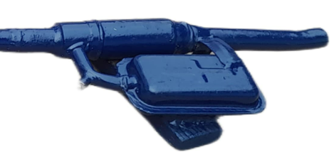

* + 1. **Fan**

A DC 12-volt fan operates using direct current (DC) electrical power supplied by a source such as a computer power supply, a battery, or a dedicated DC power adapter. Here's a basic overview of how a DC 12-volt fan works:

Power Supply: The DC fan is connected to a power source providing a steady 12-volt DC supply. This voltage is necessary to power the fan's motor and make it operational.

Motor: Inside the fan, there's an electric motor. When voltage is applied, the motor spins, causing the fan blades to rotate. The motor typically consists of coils and magnets arranged in such a way that when electricity flows through the coils, it creates a magnetic field that interacts with the magnets, causing the motor shaft to rotate.

Fan Blades: The rotating motor shaft is connected to fan blades. As the motor spins, it transfers rotational energy to the blades, causing them to rotate as well.

Airflow: As the fan blades rotate, they push air in a specific direction, creating airflow. The direction of airflow depends on the orientation of the fan blades and the design of the fan housing. For example, in a computer case fan, the airflow is usually directed from the front to the back or from the bottom to the top, depending on the fan's placement.

Cooling: The primary purpose of most DC 12-volt fans is to provide cooling. By moving air, the fan helps dissipate heat from components such as computer processors, power supplies, or electronic equipment. This prevents overheating and ensures proper operation and longevity of the equipment.

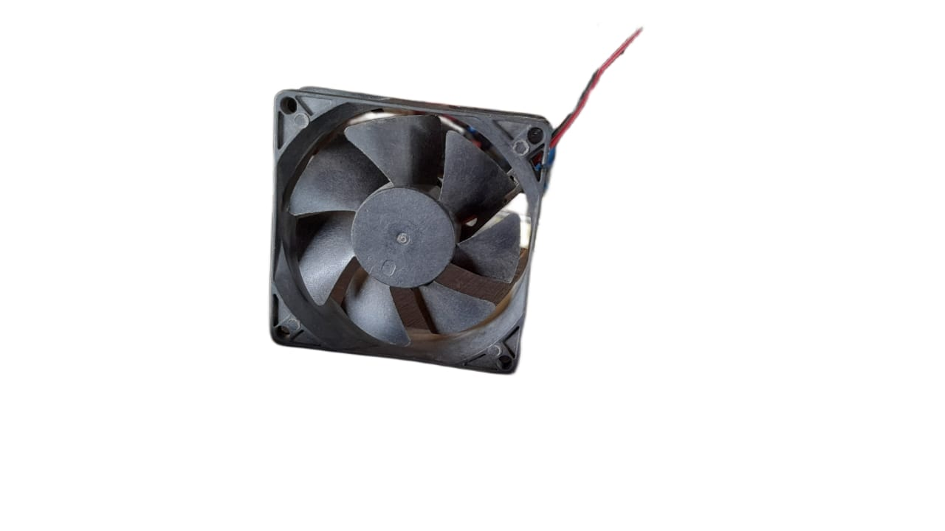

* + 1. **Rectifier**

A rectifier typically refers to a device that converts alternating current (AC) to direct current (DC). While the term "rectifier" is more commonly associated with electrical engineering, in mechanical systems, rectifiers are often used in conjunction with rotating machinery, such as generators or alternators, to convert the AC output into DC power.

One common application of rectifiers in mechanical systems is in the field of power generation. For instance, in hydroelectric power plants, wind turbines, or even some types of engines, mechanical energy is converted into electrical energy through generators or alternators. The output of these generators is typically alternating current (AC). However, many applications, such as battery charging or powering DC motors, require DC power. This is where rectifiers come into play.

Rectifiers in mechanical systems can be implemented using various technologies, including diode-based rectifiers, thyristor-based rectifiers (such as controlled rectifiers), or more advanced semiconductor-based rectifiers like MOSFET or IGBT-based rectifiers.

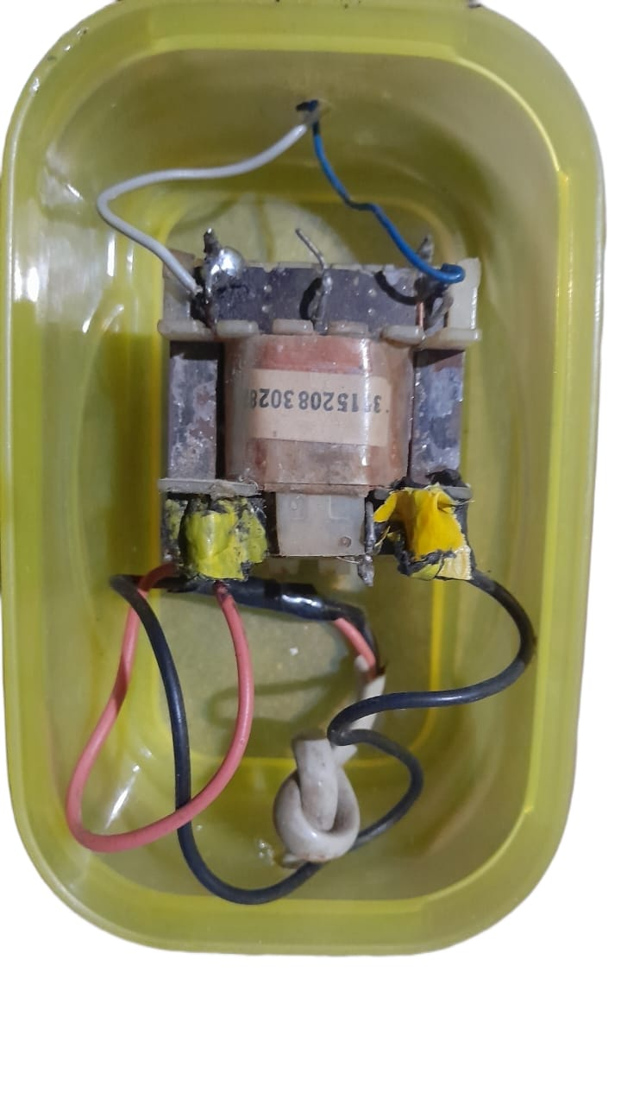

* 1. **CONSTRUCTION**

3.2.1 **Waste Input System**:

Incorporating advanced sorting mechanisms, the Waste Input System efficiently segregates various waste types. Automated conveyor belts and sensors ensure precise sorting, directing materials to their respective processing areas. Enhanced design allows the system to accommodate diverse waste streams, promoting versatility in waste management.

3.2.2 **Combustion Chamber**:

Central to the construction is the Combustion Chamber, designed to facilitate controlled burning of pre-sorted waste. Temperature control mechanisms and air-fuel ratio sensors are integrated to optimize combustion efficiency. Notably, the chamber features a two-fan system that directs the combustion gases to a High-Efficiency Particulate Air (HEPA) filter for the removal of harmful pollutants.

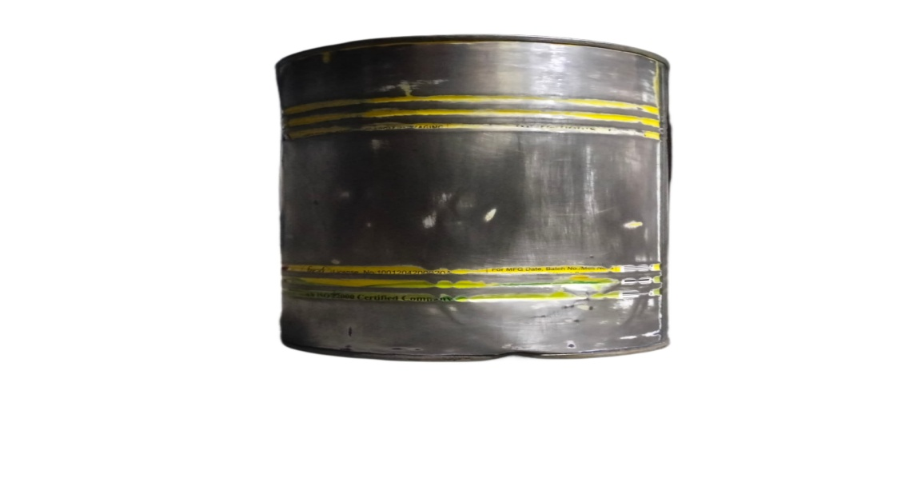

3.2.3 **Gasification/Pyrolysis Reactor**:

The Gasification/Pyrolysis Reactor, serving as the technological core, employs advanced processes to convert waste into cleaner gases or bio-oils. The two-fan system ensures that gases produced are efficiently directed to the HEPA filter, purifying them before release. This step enhances the environmental responsibility of the system by minimizing the emission of poisonous gases.

3.2.4 **Filter System**:

A critical component in ensuring environmental safety, the filter system plays a pivotal role in gas purification. Positioned after the combustion chamber and gasification/pyrolysis reactor, it effectively removes particulate matter and toxins from the combustion gases, ensuring emissions meet stringent environmental standards. The filter system contributes significantly to maintaining air quality and minimizing the release of pollutants during the combustion and gasification processes.

* 1. **WORKING**

The working mechanism of the eco-friendly waste burner is a dynamic process that begins with the introduction of pre-sorted waste into the Waste Input System. As materials move through the system, they enter the Combustion Chamber, where controlled burning takes place. The two-fan system directs combustion gases to the filter, removing particulate matter and purifying the emissions.

Subsequently, the waste undergoes gasification or pyrolysis in the specialized reactor. Gasification produces a syngas that can be used for energy generation, while pyrolysis yields bio-oil and gas. The filter system ensures the purification of gases before release, maintaining environmental standards. The final byproducts, such as ash or residues, are managed responsibly, completing the waste-to-energy cycle.

This intricate working process, coupled with the innovative use of a filter and two fans for gas purification, showcases the synergy between components, emphasizing the eco-friendly waste burner's potential to revolutionize waste management practices while prioritizing environmental safety.

* 1. **ADVANTAGES**

- Reduced Environmental Impact

-Energy Recovery

-Versatility in Waste Management

-Resource Optimization

-Environmental Responsibility

-Contribution to Sustainable Energy Generation

-Enhanced Combustion Efficiency

-Potential for Varied Waste Streams

-Mitigation of Air Quality Issues

-Alignment with Circular Economy Principles

* 1. **DISADVANTAGES**

- High Initial Construction Costs

-Skilled Maintenance Required

-Operational Constraints

-Complexity of Gasification/Pyrolysis Processes

-Potential for Residual Waste

-Need for Advanced Monitoring Systems

-Dependence on Waste Composition

-Regulatory Compliance Challenges

-Limited Scalability in Certain Settings

-Initial Learning Curve for Implementation Teams

**CHAPTER-4**

**SYSTEM SPECIFICATION**

* 1. **HARDWARE SPECIFICATION**

The hardware specifications encompass the technical details of the components used in the construction of the eco-friendly waste burner. This includes the specifications of the waste input system, combustion chamber, gasification or pyrolysis reactor, HEPA Filter System. The selection of materials, dimensions, and operational parameters will be detailed in this section, providing a comprehensive overview of the system's physical attributes.

1. Combustion Chamber.
2. Air Supply System.
3. Emission Control.
4. Control System.
5. Ash Handling System.

**CHAPTER** **5**

**MODEL REPRESENTATION**

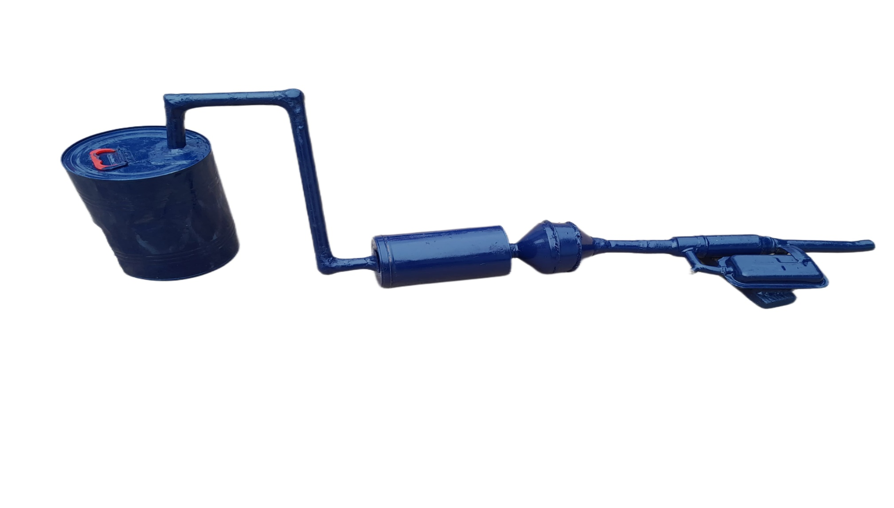

**CHAPTER 6**

**RESULT AND DISCUSSIONS**

The operational implementation of the eco-friendly waste burner has yielded promising outcomes across critical performance metrics. Emission reduction measures have demonstrated a substantial decrease in environmental impact, while the energy recovery unit has proven highly efficient in converting waste into a valuable resource for sustainable power generation. The Waste Input System showcases high accuracy in waste sorting, diverting materials away from landfills and optimizing recyclable and energy-rich components. Rigorous testing has affirmed the system's operational stability, meeting safety standards and ensuring reliable performance under diverse waste compositions. Comparisons with traditional waste incineration methods underscore the superior environmental profile and efficiency of the eco-friendly waste burner. The technology's adaptability to various waste streams positions it as a robust solution for sustainable waste management. These results signify the technology's potential to revolutionize waste disposal practices while contributing to global efforts for a more sustainable and circular economy.

**COST ESTIMATION**

|  |  |
| --- | --- |
| **PRODUCT** | **COST (in Rs.)** |
| Combustion Chamber | 400 |
| Fan | 150 |
| HEPA filter | 700 |
| **Total** | **1250** |

**CHAPTER 7**

**CONCLUSION**

The impact of the eco-friendly waste burner on waste management practices and its potential contributions to environmental sustainability will be highlighted. Recommendations for future research and practical applications may also be discussed.